**CLASS DIGRAMS**

**Areef ur Rahman(0389)**

**Task01(EmployeeAPP)**

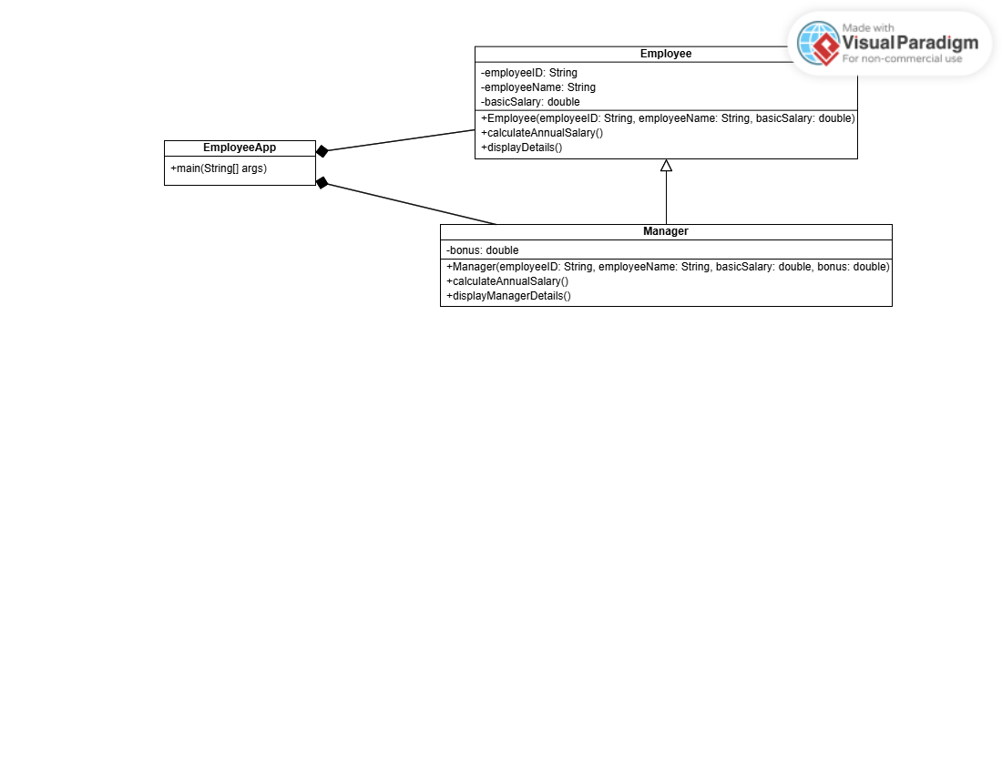

**Task02(BankApp)**

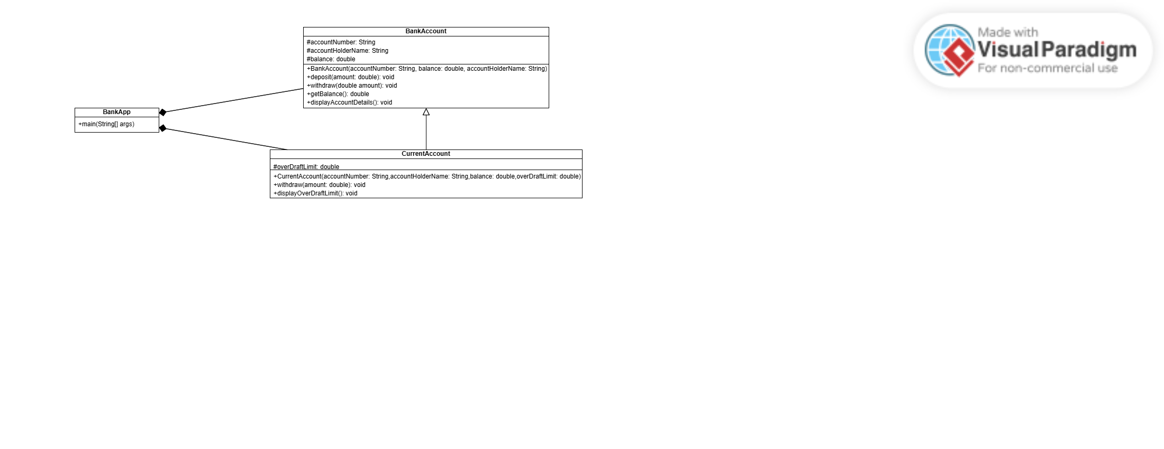

**Scenerio Based Task (SmartLightApp)**

